IILM- A platform to experience Global Study,Internships and Placement Opportunities

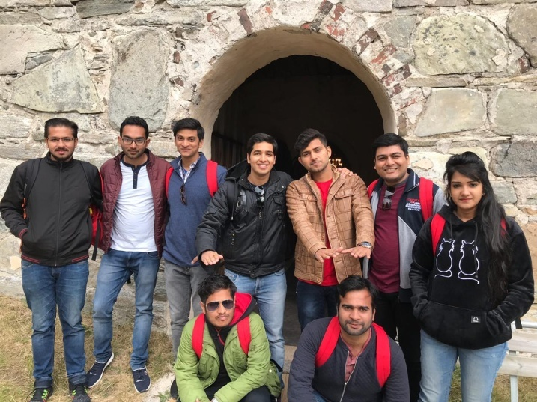
IILM has tie-ups with various international universities to foster experiential learning. It helps the students to learn vivid skills from the best professors across reputed B-Schools. IILM takes keen measures to benchmark the quality of the content delivery. With international exposure at the B-school level, students learn to conduct themselves in any environment, gain confidence and develop networking skills. Studies have shown that students with international exposure perform much better in the corporate world. Moreover, multinational exposure gives students the opportunity to understand the rules and regulations of the businesses in different countries.
Global Study at IILM:
Finland has been one of the global study destinations in their unique offering. Through thisprogram, students were able to hone their critical skills of Digital Marketing strategies and Entrepreneurship which is essential in the interconnected world.
They got the exposure to agile digital marketing trends and its application in businesses. The students also cherishedvarious team building activities and unique teaching pedagogy and assessment pattern.Many students were also appreciated for their diligence and participation in those activities. IILMstudents got an opportunity to be interviewed by aSwedish and Finish Newspaper as a platform to exhibit their learnings.
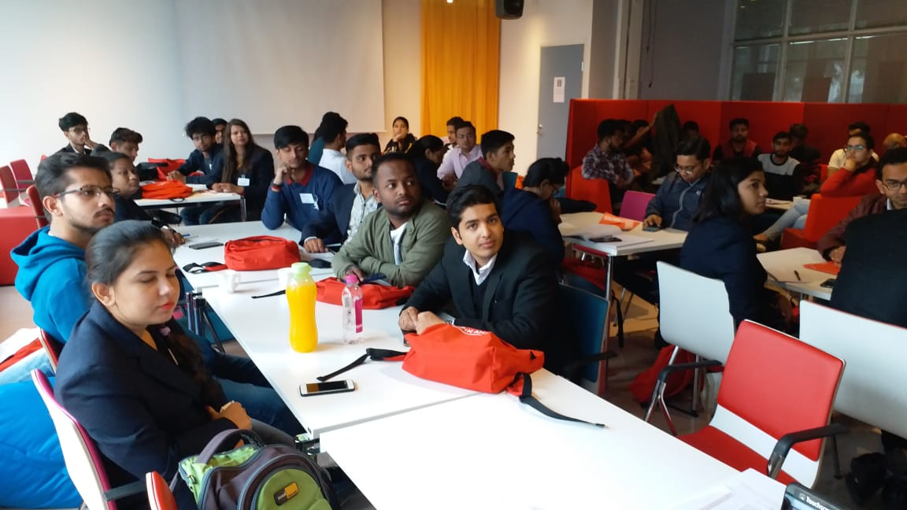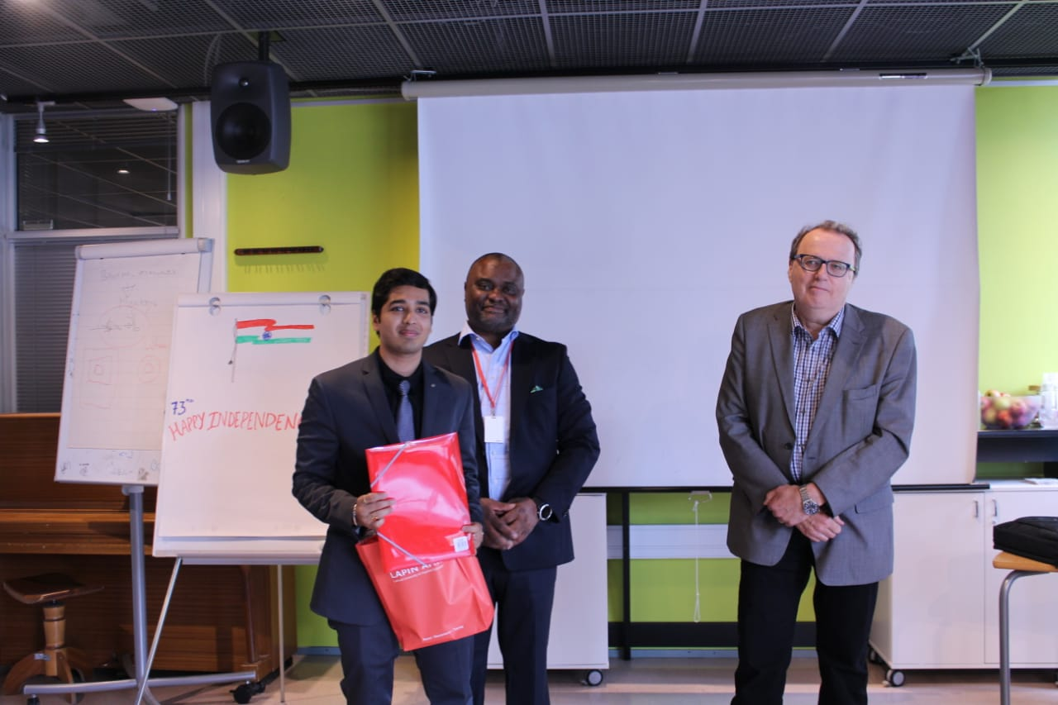

International Internship at IILM:
IILM has even offered International Internship Opportunities from the likes of AIESEC and Mataora. The creative agency ‘Mataora’ in Mauritius offered students a thrust in gaining creative and advertising edge for luxury brands. It provided them with a platform to build a global network and become placement ready.A global experience certificate is a value addition to their career ladder.

International Placements at IILM:
There are many companies which come to IILM for international placements.We had students who received international offers with an extremely good package.Landmark Group and KhimjiRamdas were such potential recruiters in the past. Indeed, out of the total opportunities, 15 companies were from the international domain and 50 % of the companies were multinational.

Dr. Shweta Nanda
(Assistant Professor, Marketing)

